

SMT201 Geographic Information Systems for Urban Planning

**Project Report**

G2T5

Danelle Goh Ruoqing

Koh Jia Wen Chloe

Lek Jie Min Jayme

Table of Contents

**1. Distribution of Young** **4**

1.1. Distribution of Young in 2014 4

1.2. Distribution of Young in 2015 4

1.3. Distribution of Young in 2017 5

1.4. Distribution of Young in 2019 5

1.5. Distribution of Young in 2020 6

1.6. Comparing 2015 and 2017 Young Population 7

1.7. Comparing 2019 and 2020 Young Population 8

**2. Accessibility to Schools** **9**

2.1. Primary Schools 9

2.2. Secondary Schools 11

2.3. Pre-Tertiary Institutions 13

**3. Conclusion** **14**

**4. Data Collection** **15**

**5. Data Preparation** **15**

5.1. School Directory and Information 15

5.2. Singapore Residents by Planning Area / Subzone 16

5.3. OSM Road Network 16

**6. Choropleth Maps** **17**

6.1. Loading the GIS Data 17

6.1.1. Masterplan 2019 Subzone 17

6.1.2. Residential Population Age and Sex 2011 to 2020 17

6.2. Creating virtual layers 19

6.3. Creating Subzone name attributes in population layers to do a Join 20

6.4. Join attributes to obtain the area for each population 21

6.5. Creating the choropleth map 22

**7. Accessibility Maps** **23**

7.1 Preparing base layer for the study area 23

7.2. Preparing schools layer 24

7.2.1. Importing data 24

7.2.2. Extracting data for respective school types 25

7.3. Extracting and preparing road network layer 26

7.3.1. Selecting all road network within the study area 26

7.3.2. Extracting desired road networks 27

7.4. Analytical Hexagon 28

7.4.1. Creating hexagon layer 28

7.4.2. Editing and saving the hexagon layer 29

7.4.3. Computing and saving the hexagon centroid 29

7.5. Network accessibility analysis with NEAT3 29

7.5.1. Working with OD Matrix Tool 29

7.5.2. Extracting shortest distance pairs 30

7.5.3. Mapping accessibility values 30

7.5.3.1. Creating a duplicate layer 30

7.5.3.2. Performing relational join 31

7.5.3.3. Creating choropleth map 31

# 1. Distribution of Young

In our analysis, we defined the young population as people aged 7 to 18 as this is the age range for primary school, secondary school and pre tertiary education.

## 1.1. Distribution of Young in 2014

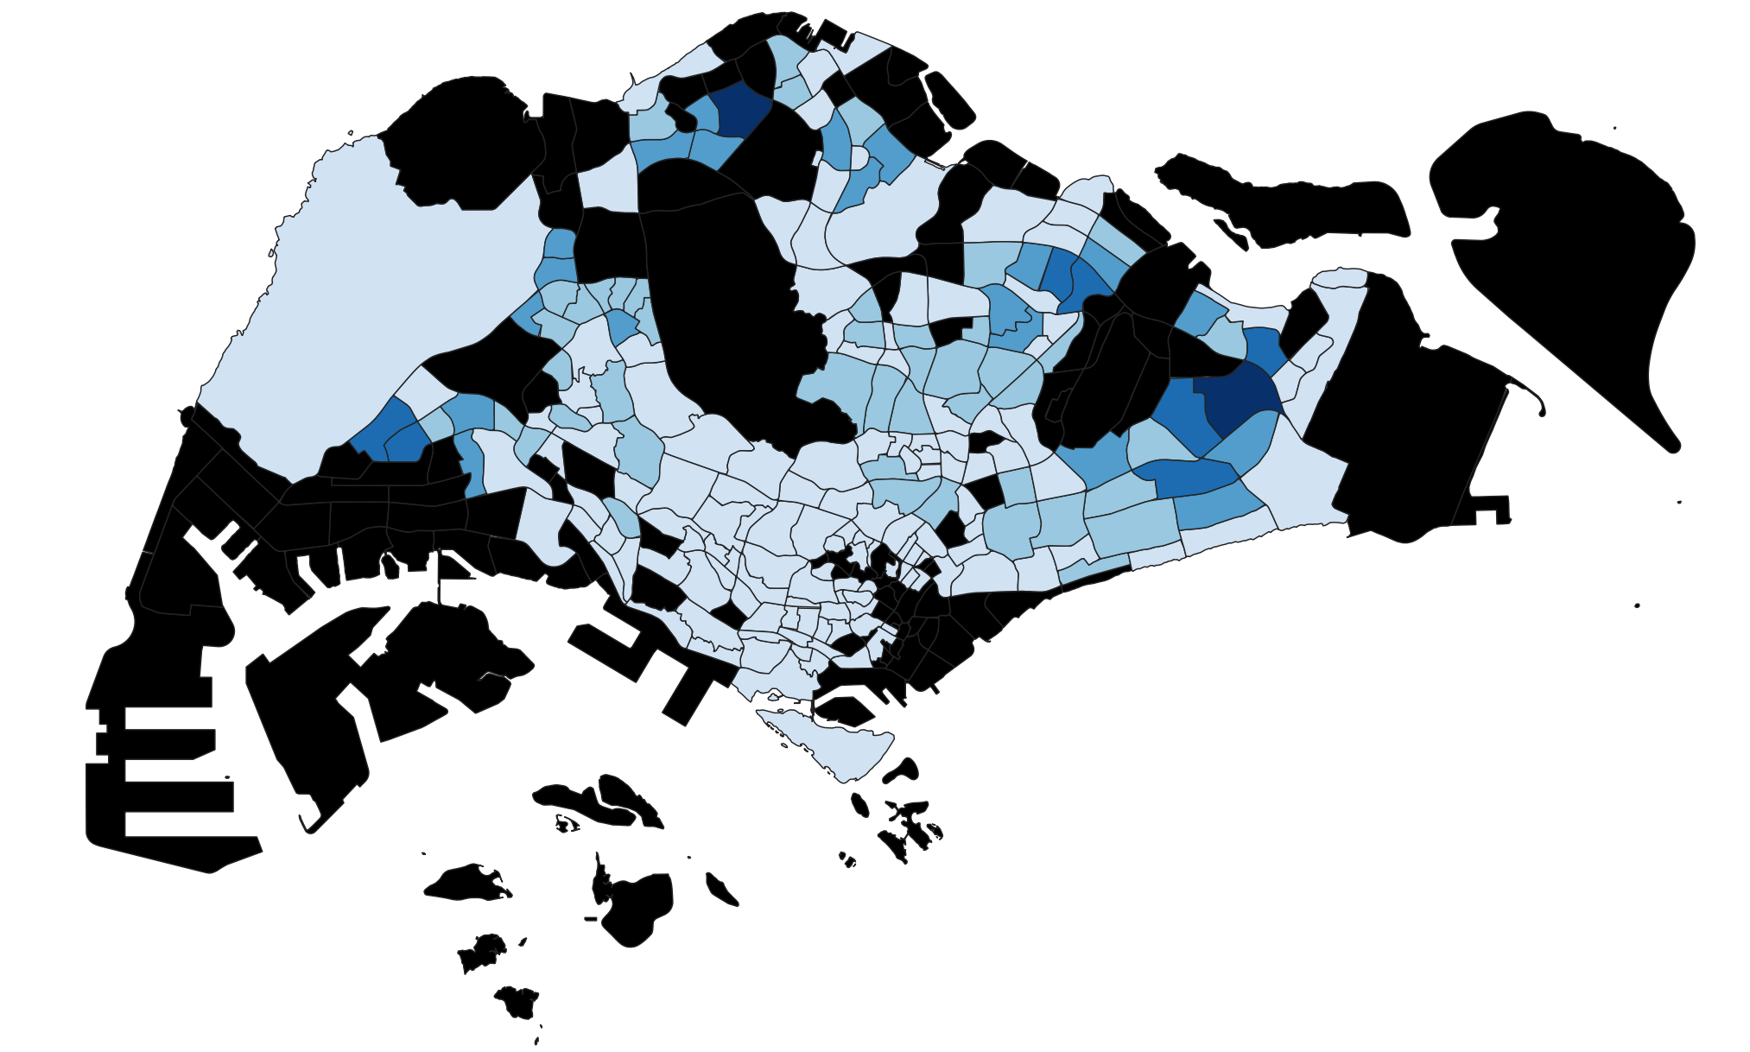

For the distribution of young people in 2014, we found that Tampines East and Woodlands East have the highest number of young people with 13975 and 17640 respectively. We also observe that the extreme West, East and North areas of Singapore are the most highly populated with young people while there are not many young people living in the Southern area of Singapore.

## 1.2. Distribution of Young in 2015

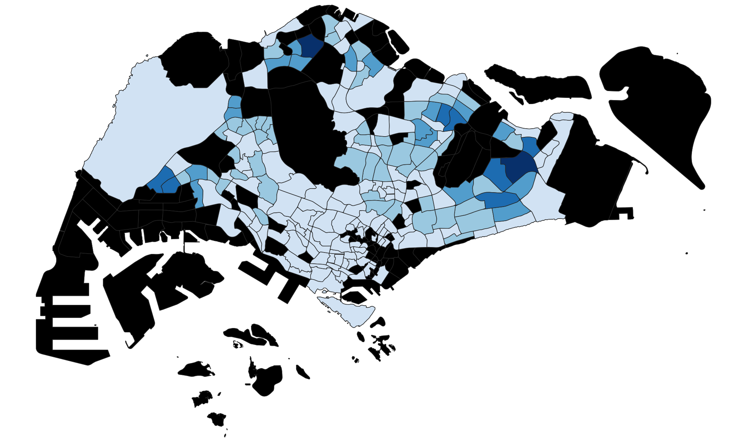

In 2015, we observed that Tampines East and Woodlands East continue to be the areas with the highest number of young people in the area. Punggol has the biggest increase in young people of 3150 compared to 2014 while Teck Whye, Peng Siang and Yishun South all faced a decrease in young population compared to 2014.

## 1.3. Distribution of Young in 2017

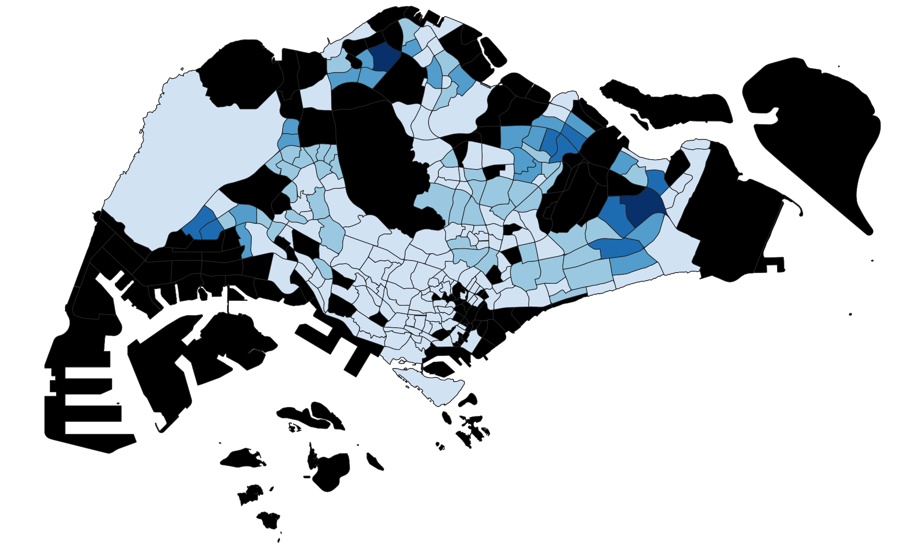

In 2017, Punggol Field, Anchorvale and Kaki Bukit all saw an increase in young people while the other areas did not see much changes. Overall, not much significant changes were observed in the young population living around Singapore and we still observe the trend of many young people in Singapore living in the extreme West, East and North regions.

## 1.4. Distribution of Young in 2019

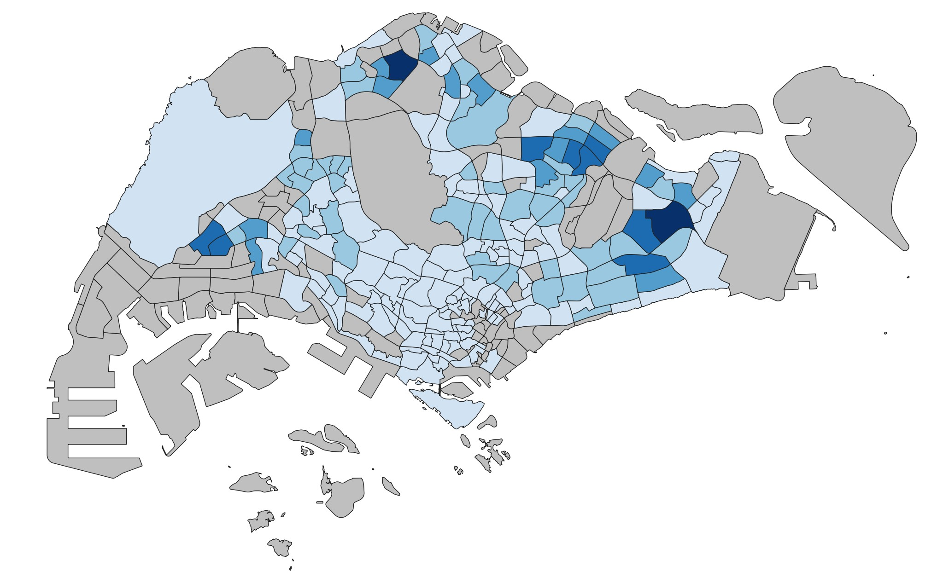

In 2019, Fernvale and Seletar saw an increase in the number of young people while other areas did not see much changes. However, this change was not very significant and the distribution of young across Singapore is similar to that of 2017.

In 2017, there was no change in the number of primary schools and pre-tertiary institutions, while there were 6 pairs of secondary schools that merged. The lack of change in distribution of young people after this merger took place implies that prospective secondary school students are not greatly affected by the decrease in accessibility.

## 1.5. Distribution of Young in 2020

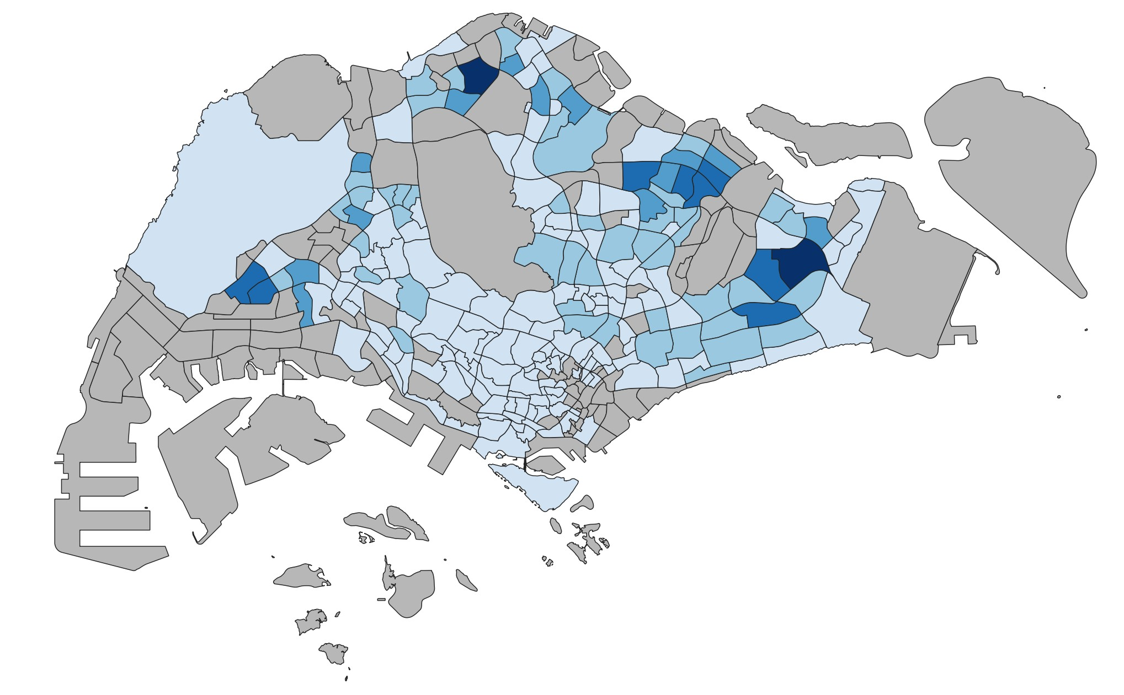

In 2020, there was an increase in the number of young people in Keat Hong, while there was a decrease in Hillview, Yuhua East and Pasir Ris West. Other than that, there is no significant observable change in the distribution of young based on the choropleth maps. There may be changes that are not captured visually as the new numbers may still fall within the same band. As such, our group decided to calculate the difference in the number of young people between selected years.

## 1.6. Comparing 2015 and 2017 Young Population

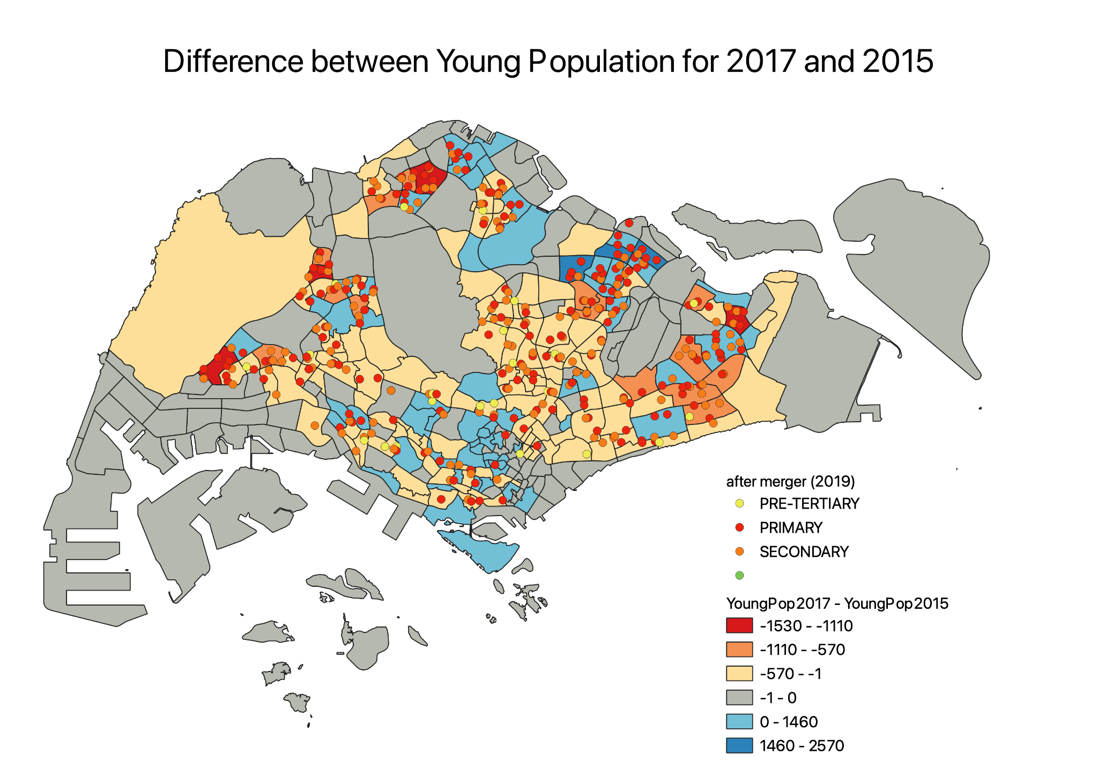

To create this map, we took the difference between the young population in 2017 and 2015. Negative numbers mean that the population in 2015 was greater than that of 2017, while positive numbers mean that the population in 2017 was greater than that of 2015.

As such, Choa Chu Kang, Yunnan, Pasir Ris Drive and Woodlands East all faced an increase in the number of young people. We can also see that these areas have many primary and secondary schools around which make them more accessible for residents living in the area, resulting in the increase in young people.

Fernvale, Punggol and Waterway East have a decrease in young people living in the area. However, these areas do not have that many schools densely populated in the area as compared to the areas with an increase in young people. Hence, these areas may not be that accessible to the schools and resulted in a decrease in young people living there.

## 1.7. Comparing 2019 and 2020 Young Population

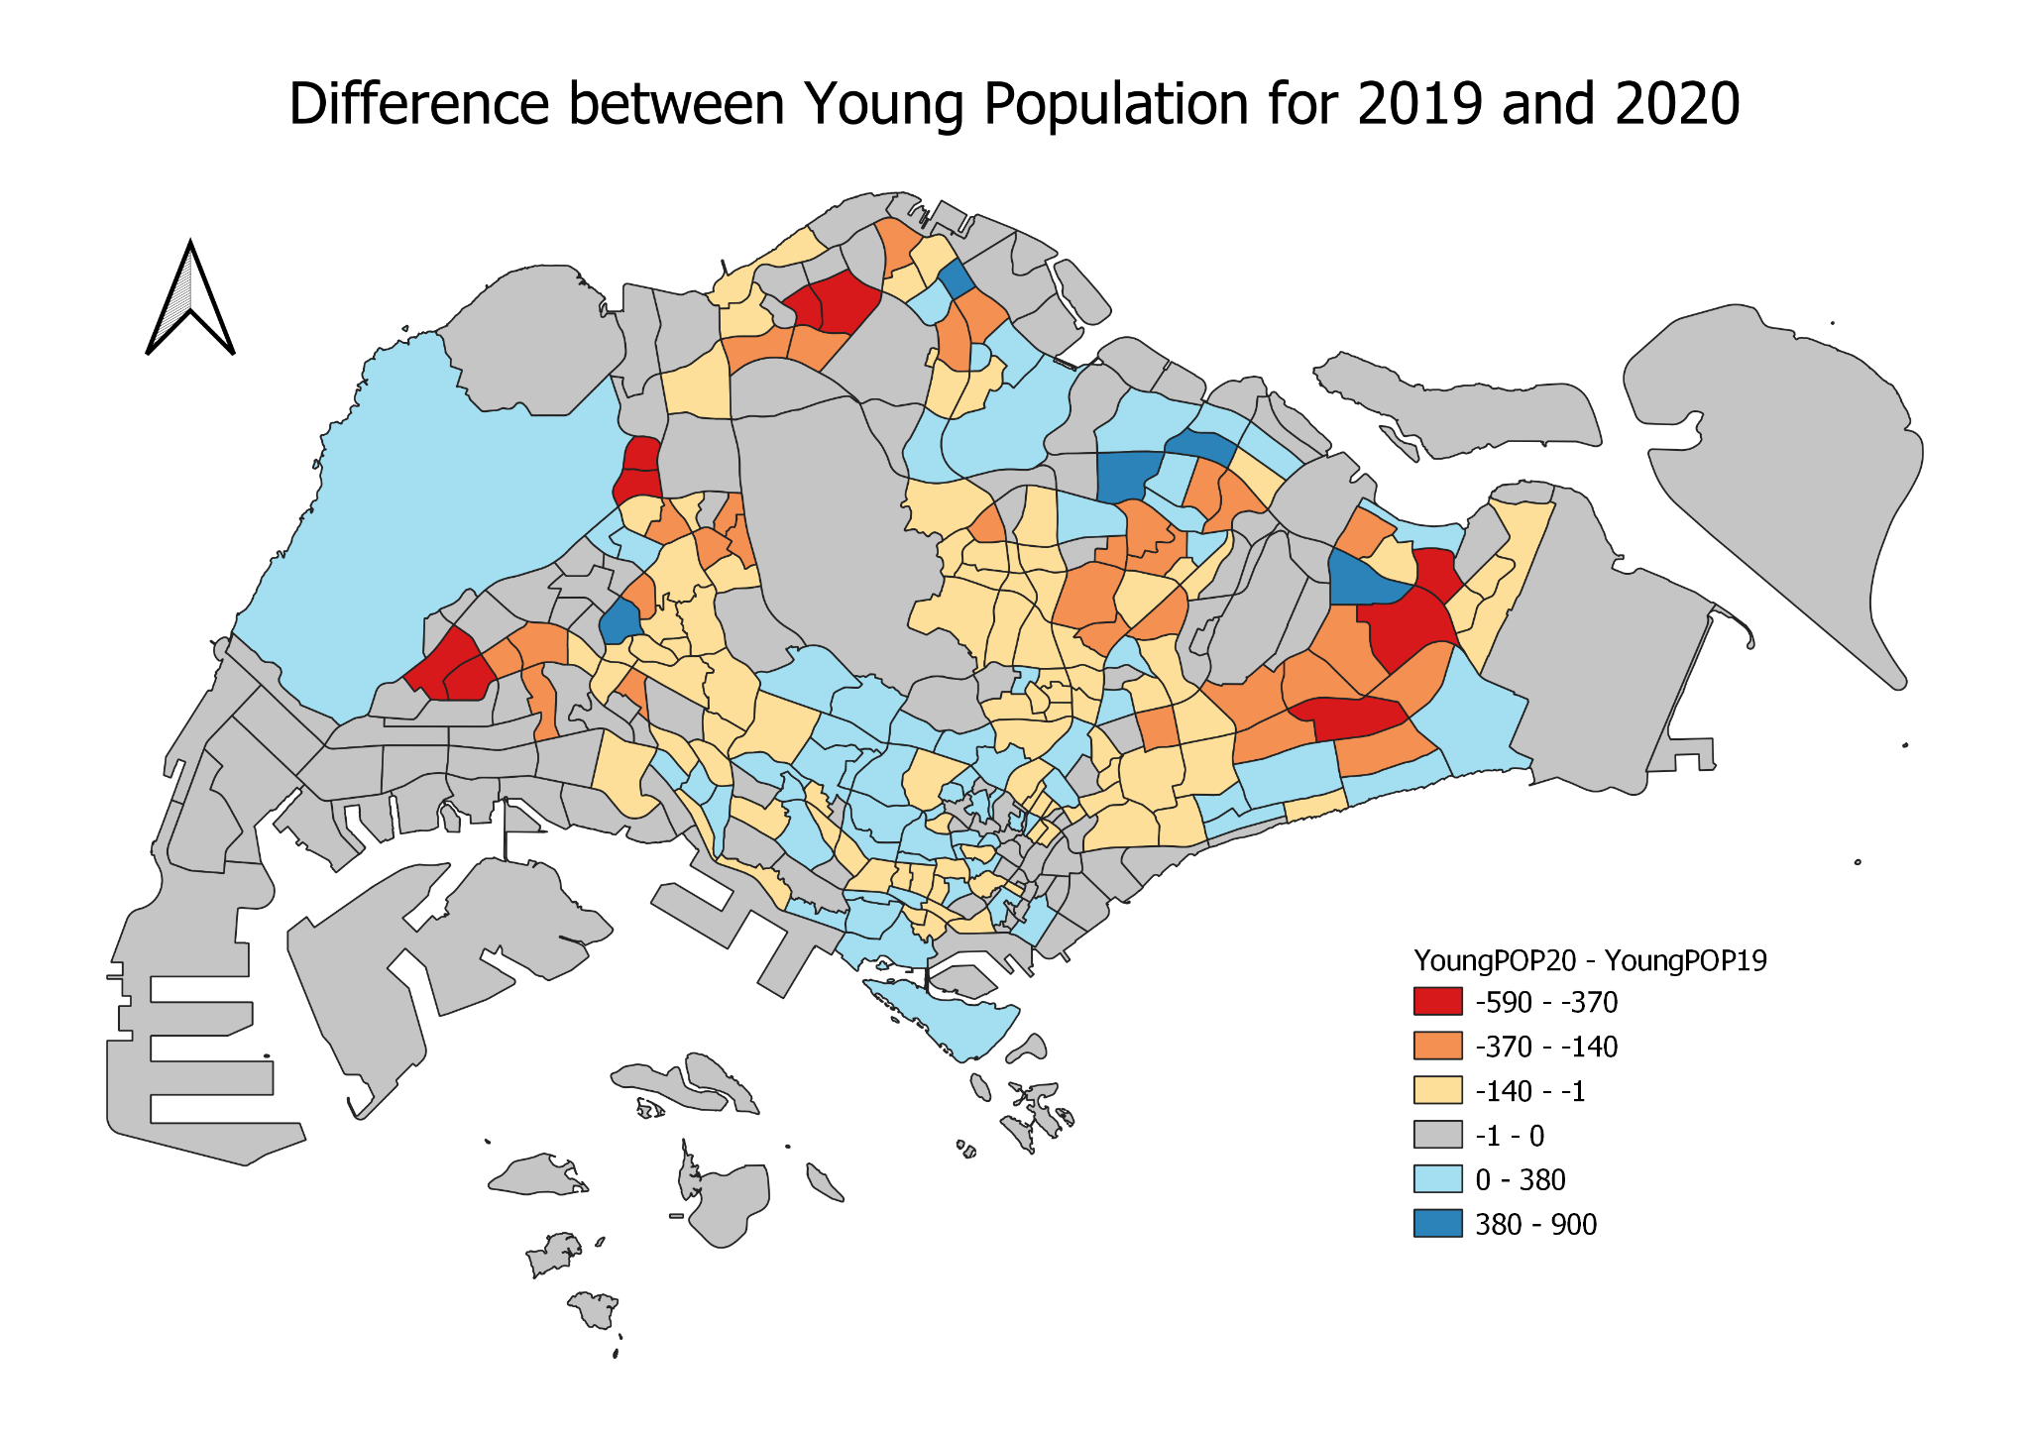

Similar to before, we created this map by finding the difference between the young population in 2020 and 2019. Negative numbers mean that the population in 2019 was greater than that of 2020, while positive numbers mean that the population in 2020 was greater than that of 2019.

From 2019 to 2020, subzones that experienced an increase in the number of young people include Fernvale, Seletar and Brickworks. On the other hand, examples of subzones that faced a decrease in the number of young people are Jurong West, Choa Chu Kang North, Midview and Bedok North.

In the East, there were two pairs of primary schools that were merged in 2019 – Casuarina Primary School and Loyang Primary School, and White Sands Primary School and Coral Primary School. Although there is a subzone with a large number of young people (Tampines North – dark blue), the neighbouring subzones (Tampines East and Pasir Ris Drive – red) had experienced a decrease in the number of young people. Hence, the decision to merge schools in this area seems to be justifiable as the demand for primary school education is likely to have decreased.

# 2. Accessibility to Schools

## 2.1. Primary Schools

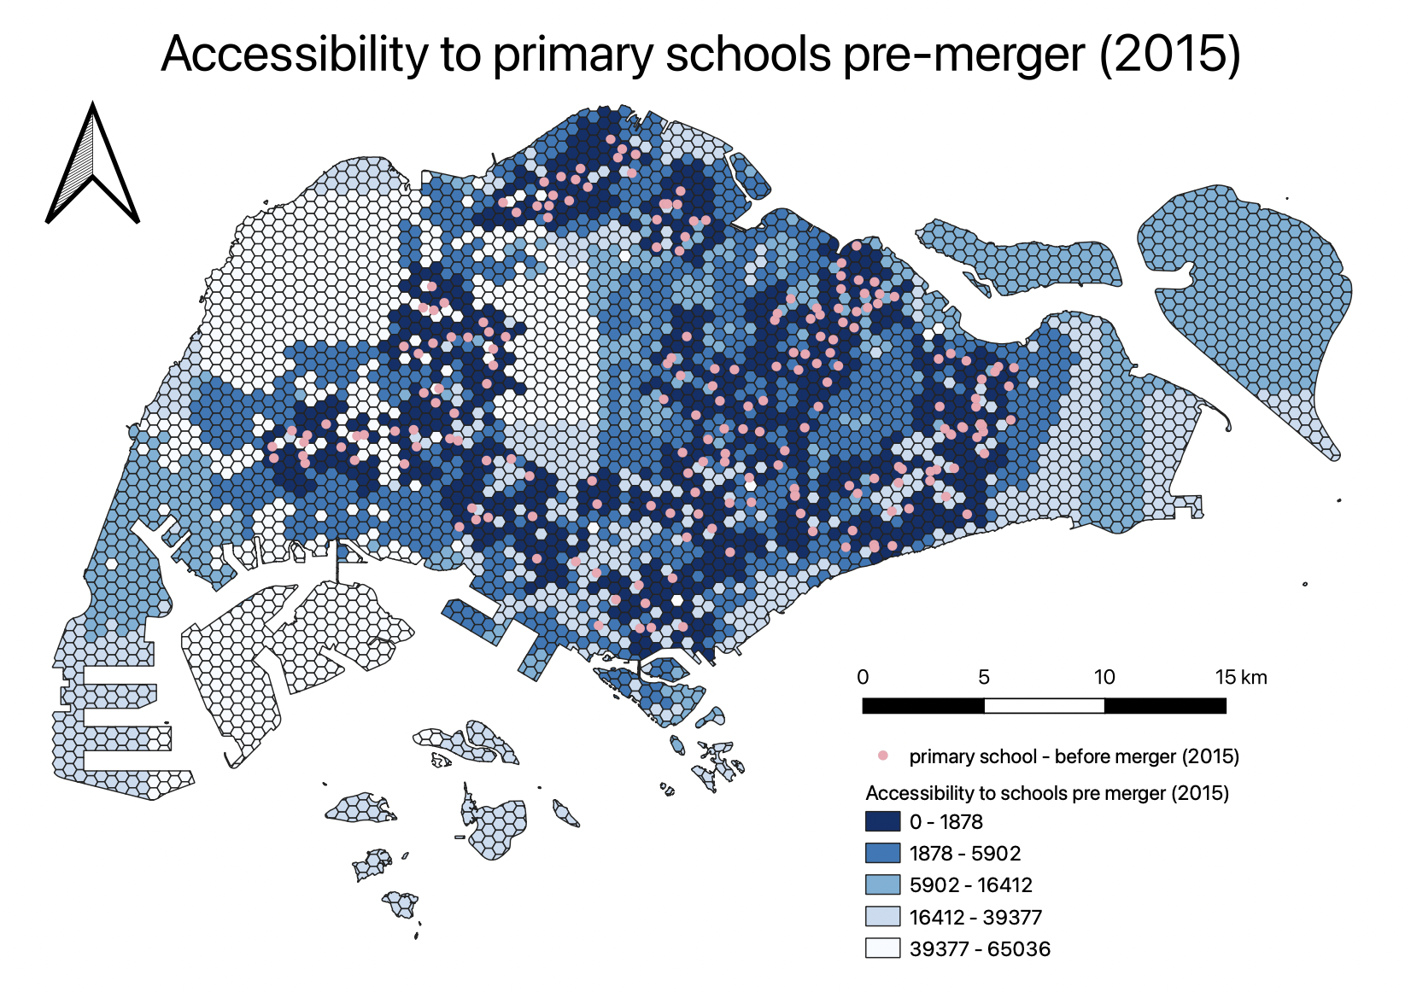

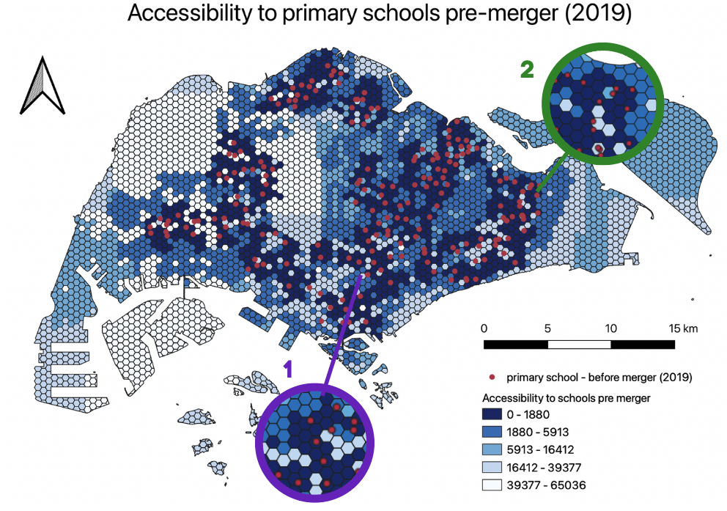

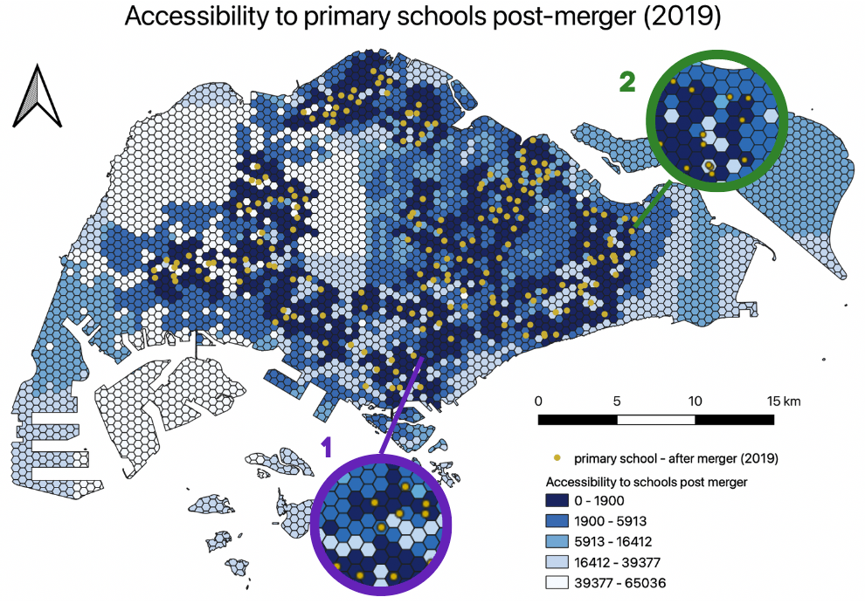

Amongst the years we analysed, the merger of primary schools in 2019 resulted in the greatest change in accessibility, with 7 pairs of primary schools being merged, whereas only 4 pairs of primary schools were merged in 2015. No primary schools were merged in 2017. Hence, we will be focusing our analysis on the 2019 merger. Even in 2019, the **change in accessibility was not very significant** as we realised that the primary schools that were merged together were usually done for schools in close proximity. The quantile values for shortest distance are also mostly unchanged, with the only exception being the first band. In the highlighted Area 1, Balestier Hill Primary School and Bendemeer Primary School were merged together. With this merger, the accessibility in the surrounding areas decreased slightly. One example of how the shortest distance changed, was from 1628m to 2479m.

In the highlighted Area 2, two pairs of schools were merged — Casuarina Primary School and Loyang Primary School, and White Sands Primary School and Coral Primary School. Similarly, even though two pairs of schools were merged, the accessibility was not greatly affected as the schools were all in close proximity to one another.

Overall, although the accessibility to primary schools decreased, the equity of access to primary schools was not greatly affected, due to the government choosing to merge schools that were already in close proximity. Additionally, there are a large number of primary schools, so each merger would not have as significant an impact on accessibility as compared to pre-tertiary institutions.

## 2.2. Secondary Schools

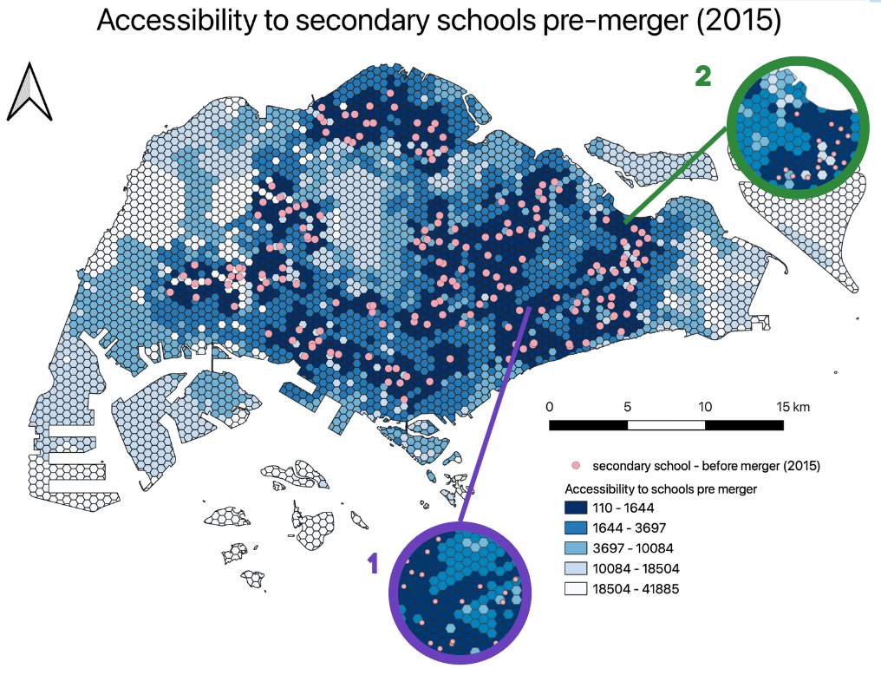

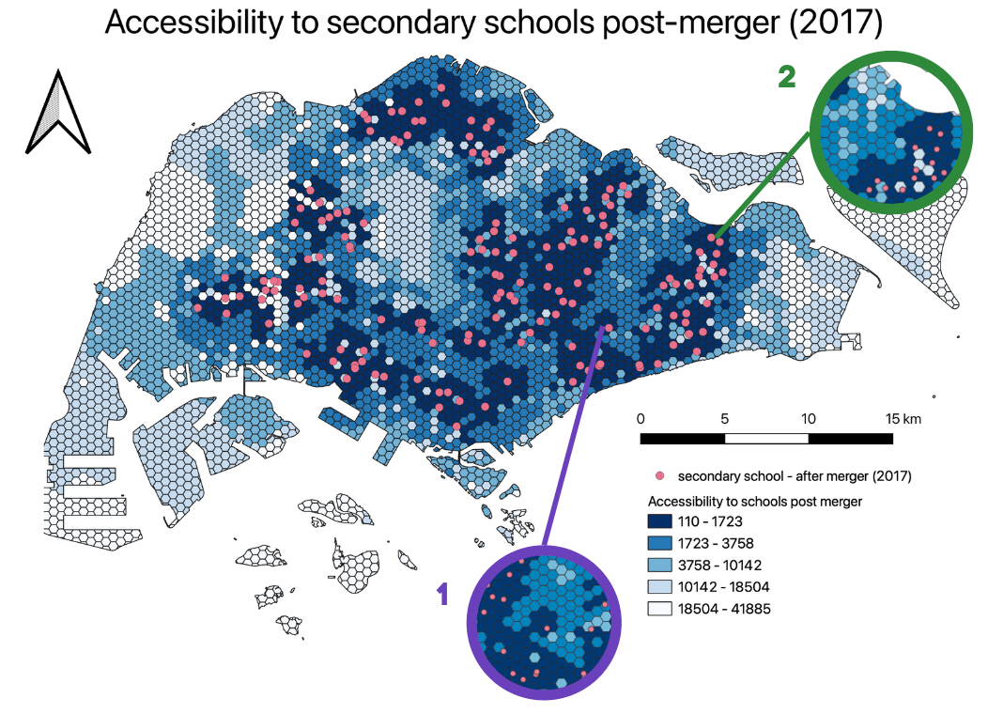

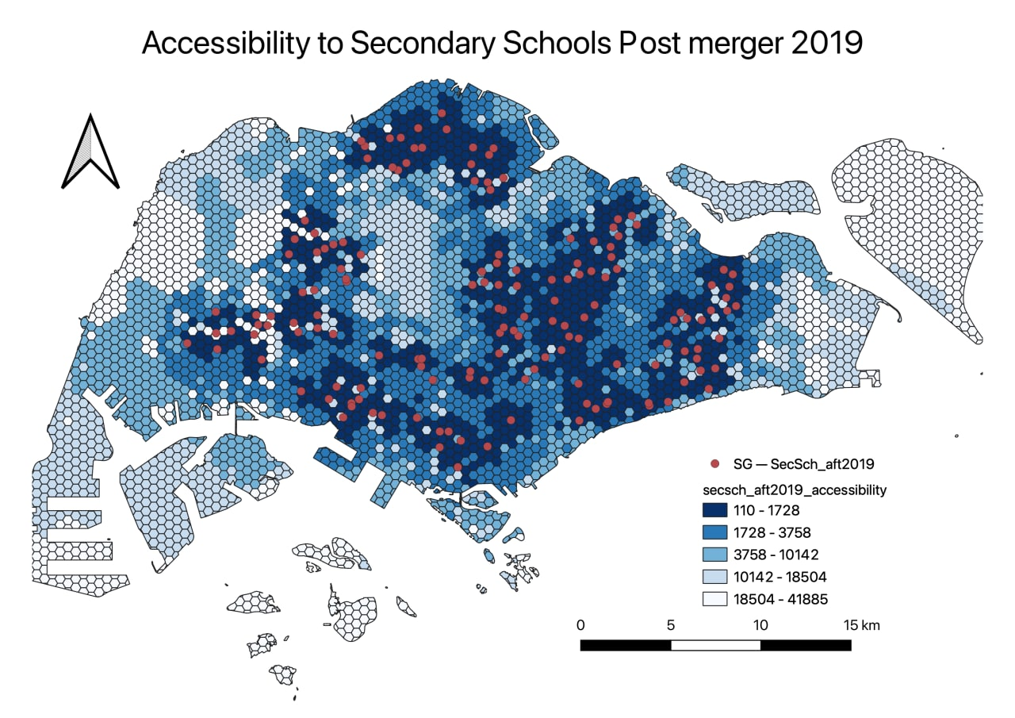

The merger of 6 pairs of secondary schools in 2017 resulted in the greatest changes in accessibility to people. As such, our analysis for secondary schools will be focused on the 2017 merger. Overall, there was a **decrease in accessibility** as the areas that used to be of short distances of range 110-1644 from a school saw an increase in distance to the range 1723-3758.

In the highlighted Area 1, the merger of Damai Secondary School at Bedok and Manjusri Secondary School at Ubi has resulted in a larger decrease in accessibility as these schools are around the same area. As a result, residents living in the area used to have 3 schools near them but after the closure of the 2 schools, there is only 1 school nearby. Hence, secondary schools are not as accessible as before for these residents as seen in the shortest distance increasing from 1196m to 1951m.

In the highlighted Area 2, the merger of Siglap Secondary School at Pasir Ris has decreased accessibility to secondary schools for those living in the area. As seen in the diagram, the presence of Siglap Secondary School made it accessible for more residents as the area of high accessibility is larger. However, after the merger, the residents in this area. The shortest distance to the nearest school of the area where Siglap Secondary School is located increased from 110m to 2522m.

Hence, while there is an overall decrease in accessibility to secondary schools from the mergers, the impact is not extremely significant to the point where equity to access is compromised. This is due to the large number of secondary schools that are already present in Singapore and located in many different regions in Singapore. However, this is with the assumption that secondary school students travel to school by public transport and/or by foot which may not apply for everyone. Furthermore, certain people and families may prefer to go to more prestigious schools which are mostly located in the central area and are considered inaccessible to certain groups of people.

## 2.3. Pre-Tertiary Institutions

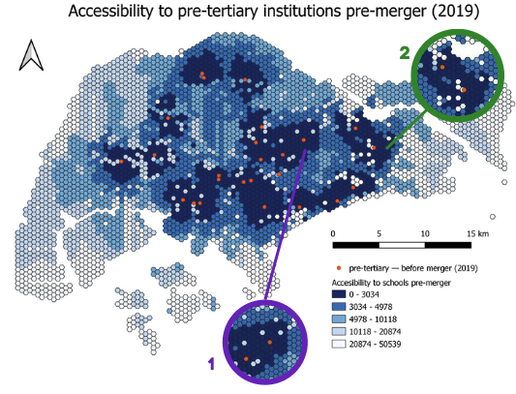

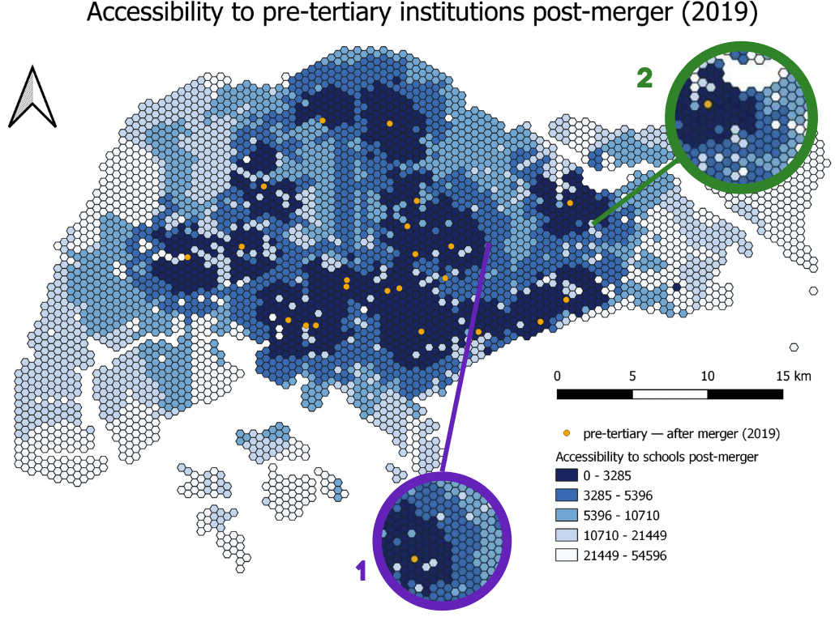

Out of the three education levels our team analysed, mergers of pre-tertiary institutions had the greatest impact on accessibility. This is likely because there were originally not many Junior Colleges (JC) and there was a considerable distance between the various pre-tertiary institutions before merger, hence this merger had a greater decrease in accessibility compared to primary and secondary schools. While our study included Polytechnics, International Baccalaureate programs, and other schools, only 4 pairs of JC, each in different regions of Singapore, were merged as part of the College Rejuvenation Programme by the government. This was in response to decreasing enrollment rates for JC.

In the highlighted Area 1, Serangoon Junior College merged with Anderson Junior College, resulting in both schools moving to Anderson Junior College's original campus and the closure of Serangoon Junior College's existing campus. This decreased accessibility for students living in the Hougang subzone. This can be seen as the shortest distance to the nearest JC for students living in Hougang increased from 3034 to 5396.

In the highlighted Area 2, Tampines Junior College merged with Meridian Junior College, resulting in both schools moving to Meridian Junior College's original campus and the closure of Tampines Junior College's existing campus. This decreased accessibility for students living in the Tampines subzone as the shortest distance to the nearest JC for students living in Tampines increased from the range 3034 to 5396.

To sum up, the mergers of pre-tertiary institutions, specifically Junior Colleges, definitely brought about decreased accessibility for students as there were already a limited number of JC to start with. However, in the grand scheme of things, the mergers were necessary given the decreasing enrolment rates which were predicted to fall to as low as 200 to 300 students. Hence, the mergers were needed to prevent a waste of resources and inefficient manpower allocation.

# 3. Conclusion

In conclusion, the merging of schools in Singapore has brought about an overall decrease in accessibility to schools across Singapore. However, while there was a decrease in accessibility, this change is still minimal as schools that were merged were in close proximity to one another. Should the government need to merge more schools, it would be advisable to continue merging schools that are already in close proximity. The impact of merging schools that are further apart from one another can be observed from the merger of pre-tertiary institutions. However, we acknowledge that as people get older (e.g. primary school students vs pre-tertiary students), they are likely to be more willing to travel a longer distance.

That being said, these mergers may have underlying implications on costs and standard of living which we are unable to observe directly from the visual differences between the maps. One reason for an increase in costs of living is due to the increase in time needed to travel as schools are now further away. Additionally, there may be an increase in costs as people who could previously walk to school now need to take public transport, and even for people who previously took public transport, the distance they need to travel now may be greater than before.

However, our group still believes that even though there was a decrease in accessibility, the changes were minimal, hence the equity of access to schools in Singapore is still maintained.

# 4. Data Collection

The datasets we have used for our project are as follows:

1. education (School Directory and Information)
   1. Description: Provides information about primary schools, secondary schools and junior colleges.
   2. Source: data.gov.sg
2. MP19 (Master Plan 2019 Subzone Boundary (No Sea))
   1. Description: Provides information about the Urban Redevelopment Authority’s (URA) regions, planning areas and subzones.
   2. Source: data.gov.sg
3. POP2020 (Singapore Residents by Planning Area / Subzone, Single Year of Age and Sex, June 2011-2020)
   1. Description: Provides multiple years of population data by age group as at June 2020.
   2. Source: Department of Statistics (DOS), Singapore
4. gis_osm_roads_free_1 (OSM Road Network)
   1. Description: Provides data on all roads and road types.
   2. Source: Geofabrik

# 5. Data Preparation

## 5.1. School Directory and Information

These are the steps we took to prepare the education.csv file for our QGIS artefact.

1. Firstly, to obtain the Longitude and Latitude of schools, education.csv was geocoded by using SLA OneMap Api.
2. Next, as education.csv only contained data of schools from 2021 after the mergers and closures, we manipulated the data by manually unmerging the schools and creating a new excel sheet for each year.  
   Data was manipulated using information from the following websites:
   * fionaseah.com: [HISTORY: Closed and Merged Schools in Singapore](https://fionaseah.com/category/general-knowledge/closed-schools-in-singapore/page/2/)
   * fionaseah.com: [HISTORY: Closed and Merged Schools in Singapore (Part 4)](https://fionaseah.com/category/general-knowledge/closed-schools-in-singapore/)
   * The Straits Times: [New names of merging junior colleges to be combination of original names](https://www.straitstimes.com/singapore/education/new-names-of-merging-junior-colleges-to-be-combination-of-original-names)
   * The Asian Parent: [School Merge in Singapore](https://sg.theasianparent.com/school-merger-in-singapore)
3. Finally, we re-categorised all education institutions into 3 categories (Primary, Secondary, Pre-tertiary) by manually editing their mainlevel_code attribute.

## 5.2. Singapore Residents by Planning Area / Subzone

1. As the Singapore Residents by Planning Area / Subzone, Single Year of Age and Sex, June 2011-2020 file contains population data for all years from 2011-2020, we used SQL to extract population data from Year 2020.
2. Next, we used SQL to extract only data from ages 7-18, which are the schooling years, before exporting this cleaned dataset into our GeoPackage.

## 5.3. OSM Road Network

Our study was based on the assumption that students have different means of transportation depending on which education level they belong to. Hence, we extracted different road types from the OSM Road Network for each level.

1. For primary schools, we only looked at walking paths.
2. For secondary schools, we will be looking at both walking paths and motor vehicle road networks.
3. For pre-tertiary institutes, we will also be looking at both walking paths and motor vehicle road networks.

More detailed steps on the extraction of different road types can be found in section 7.3.2.

# 6. Choropleth Maps

## 6.1. Loading the GIS Data

Before you can start to perform any analysis, you need to load all the appropriate GIS data into QGIS.

### 6.1.1. Masterplan 2019 Subzone

We will first add our Masterplan 2019 Subzone into our GIS Layer, this will serve as the base map layer for our study. It contains polygons for the land spaces in Singapore.

Hover over to Layer tab > Add Layer > Add Vector Layer…

Click add vector layer and you should be able to see the Data Source Manager | Vector, select the master-plan-2019-subzone-boundary-no-sea-geojson.geojson file.

### 6.1.2. Residential Population Age and Sex 2011 to 2020

This Data Layer provides the population of different age groups at different locations in Singapore in a CSV file.

Firstly, add in respopagesex2011to2020.csv, under Layer tab > Add Layer > Add Delimited Text Layer.

Once you clicked on Add Delimited Text Layer you should see the Data Source Manager | Delimited Text. You should search for respopagesex2011to2020.csv.

After adding the csv file, it will appear under Layers.

Before you can perform attribute query, you need to examine the respopagesex2011to2020.csv layer carefully to identify the appropriate field and object name (s) to query.

* At the Browser pane, right-click on respopagesex2011to2020.
* From the context menu, select Open Attribute Table.

The Attribute Table window appears.

In our study, we are only interested in finding the populations in years 2014, 2015, 2017, 2019, 2020. Hence, we can filter out the desired data using the Expression icon.

Now, you are going to enter the expression.

* From the Expression pane, click on “=” icon.

Next, you are going to complete the query statement by providing the field value.

* At the Values pane, click on the all unique button.

Your screen should look similar to the figure below.

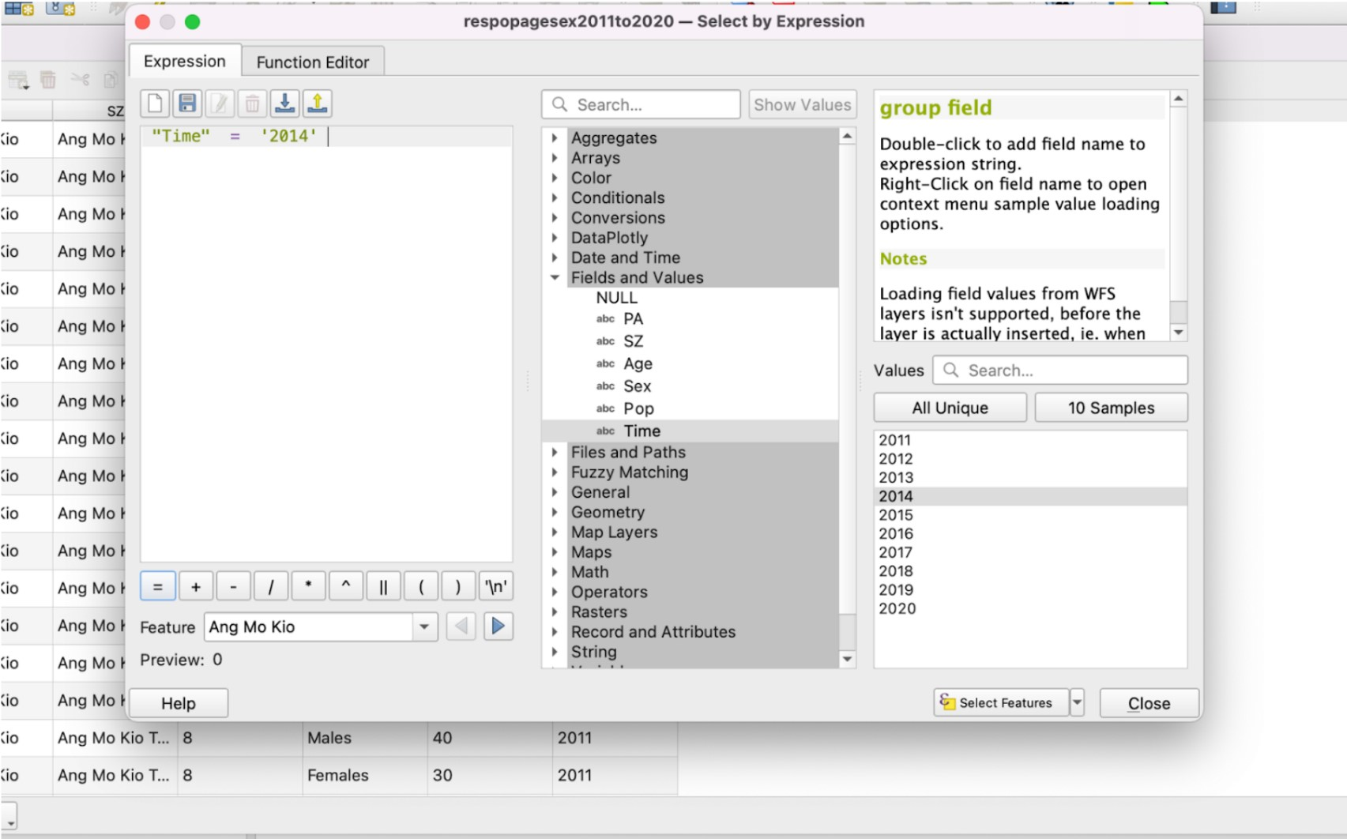

Change the year accordingly to 2014, 2015, 2017, 2019, 2020.

After entering the query, click on Select Features and close the window. We will see that all the data with “Time” = ‘2014’ selected only as shown below.

Close the attribute table and right click on the layer. Go to Export > Save Selected Features As.. to save the layer with only 2014 values into a new GeoPackage layer.

We will name this exported layer as Population2014.

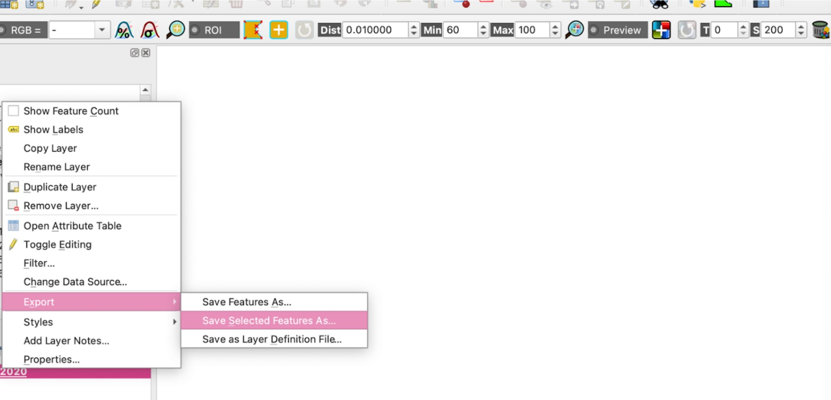

Repeat the steps to obtain the data for the other years.

After exporting the layers, we should see them appear on the Layers tab as shown below. We can now remove the respopagesex2011to2020 layer.

## 6.2. Creating virtual layers

Now that we have all the data that we need for analysis, we want to get the geographical distribution. We will do so by creating a virtual layer and using SQL statements to get the data to be shown on the map.

Layers > Create Layer > New Virtual Layer

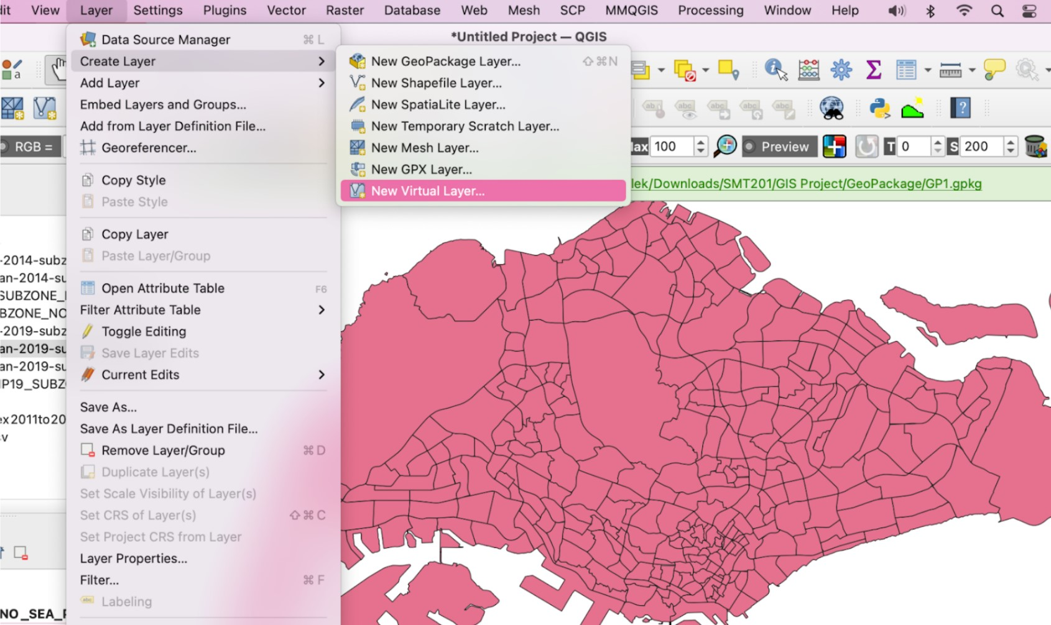

We will create 5 different virtual layers, Young_Population2014, Young_Population2015, Young_Population2017, Young_Population2019, Young_Population2020.

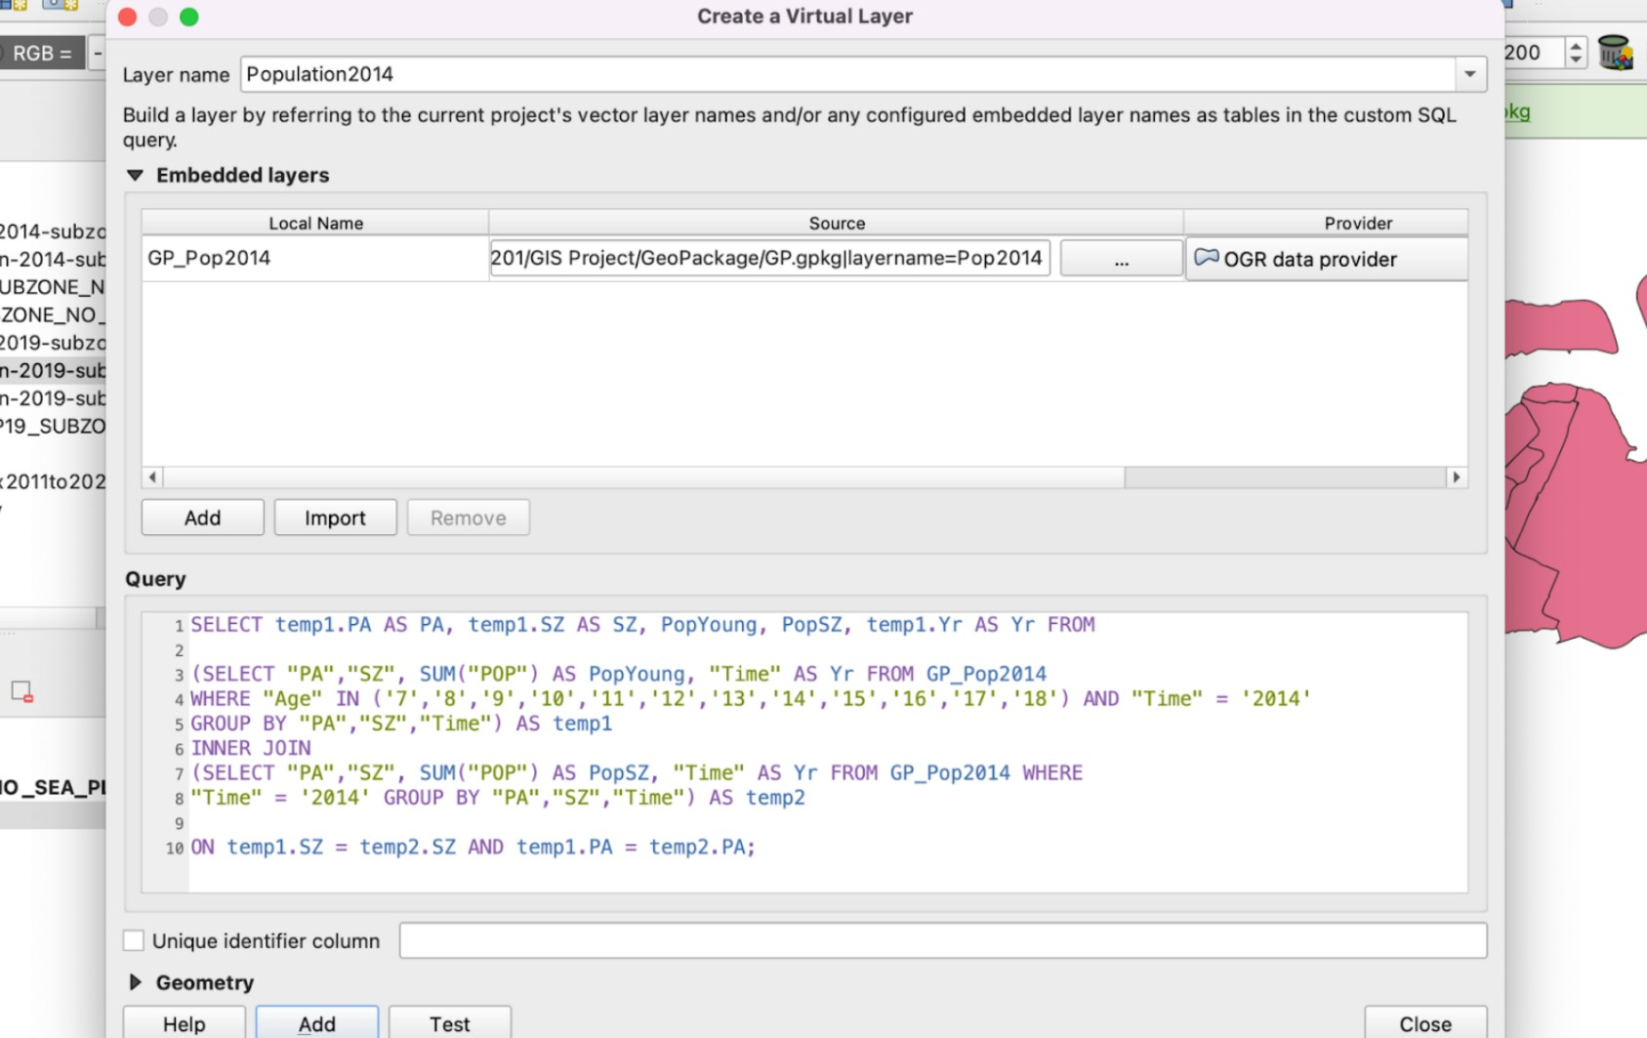

Import the GeoPackage layers under Embedded layers and enter the following query in the query tab.

After adding, a new layer is created. To better understand, let’s open the attribute table of this new layer. We see 2 new attributes created: PopYoung and PopSZ.

## 6.3. Creating Subzone name attributes in population layers to do a Join

To do a Join, we need to find a common attribute between 2 tables. However, we notice that the column SZ in our Population layers are all in lowercase while that of the Subzone layers are in uppercase. Hence, we will add a new attribute in the population layers as SUBZONE.

Right click on the layer name and select Open Attribute Table > Open Field Calculator

Fill in the Output field name as SUBZONE, output field type as Text and the following expression into the Expression tab.

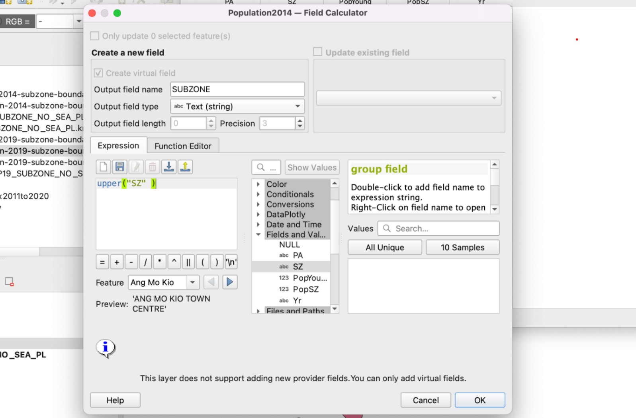

After clicking OK, we see a new column SUBZONE created which is now in uppercase.

## 6.4. Join attributes to obtain the area for each population

Now that all the required data are present, we can now perform a join. When we perform a join, we will join based on the common attributes that both layers have, which in this case is SUBZONE of the population layers and SUBZONE_N of the subzone layers.

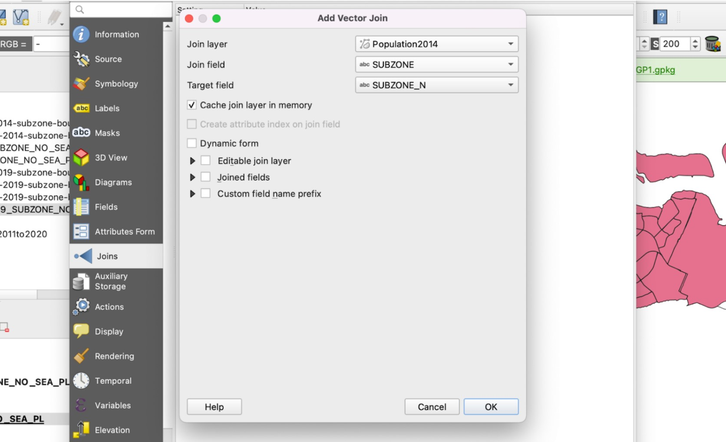

Right click on the URA_MP19_SUBZONE_NO_SEA_PL layer > Properties.. > Joins

* For the Join layer, we select the year that corresponds to the subzone layer used.
* For the Join field, we select SUBZONE
* For Target field, we select SUBZONE_N

Then select OK. We will see the joined layer under the join tab.

## 6.5. Creating the choropleth map

To create a choropleth map, right click on the Subzone layers where we performed the Join previously and select Properties > Symbology

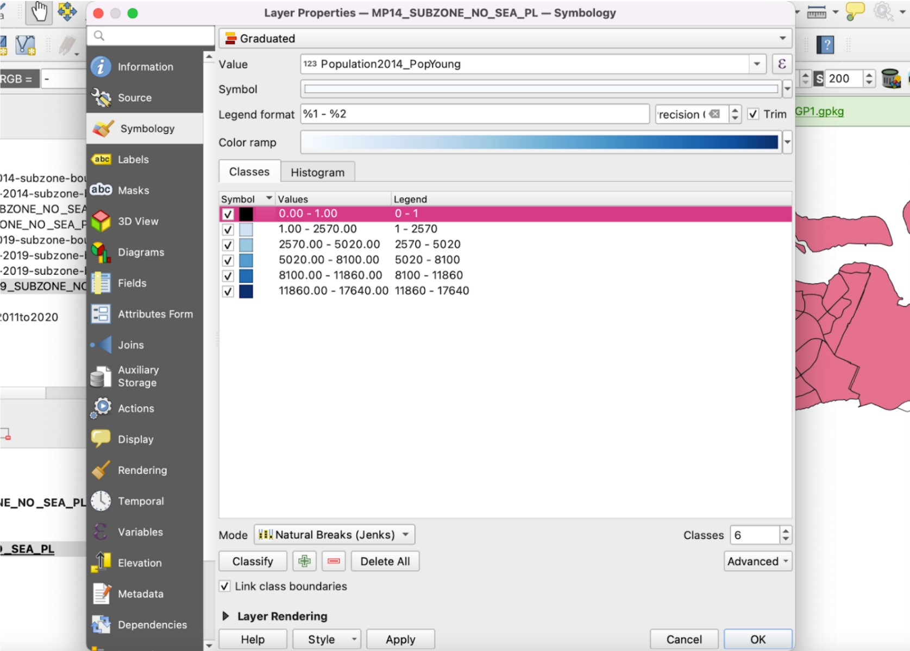

* Select Graduated from the dropdown box at the top
* For the Value, select the PopAged column that we have obtained from the join.
* For the Mode, we will be using Natural Breaks (Jenks).
* For Classes, we will select 6. This is because we want to isolate the areas where there is 0 population, in other words, inhabitable. Hence, there will be a total of 5 ranges and an additional one to represent inhabitable areas.
* We will change the colour of the inhabitable areas with range 0-1 to a distinct colour such as black so that we can easily distinguish it.
* As for the Colour ramp, we will be selecting Blues.

As we will be comparing across the different years, we need to standardize the ranges for our choropleth map for all maps. We will use the following values:

* 0 - 1
* 1 - 2570
* 2570 - 5020
* 5020 - 8100
* 8100 - 11860
* 11860 - 17640

These values have been selected as the largest value for all Young population is 17640 and we want 5 classes, so we take the ranges of 17640/5.

# 7. Accessibility Maps

## 7.1 Preparing base layer for the study area

Download Master Plan 2014 Subzone Boundary from data.gov.sg and import it into QGIS. To do this, select **Layer** > **Add layer** > **Add vector layer**.

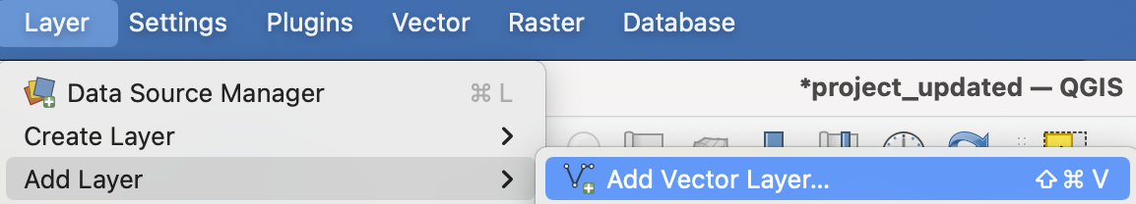

The **Data Source Manager** dialog window appears. For Vector Dataset(s), select MP14_SUBZONE_NO_SEA_PL.shp.

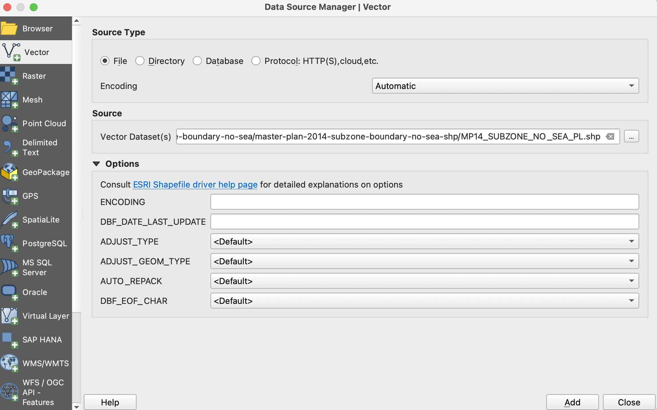

Click **Add**. Click **Close**.

Save the layer into GeoPackage format. Right click on the layer and select **Export** > **Save Features As**.

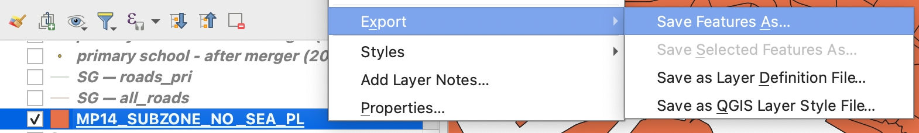

The **Save Vector Layer as** dialog window appears. For Format, select GeoPackage. For File name, select the SG GeoPackage you previously created. For Layer name, enter MP14. For CRS, select Project CRS: EPSG:3414 - SVY21. Your dialog window should look like the screenshot below.

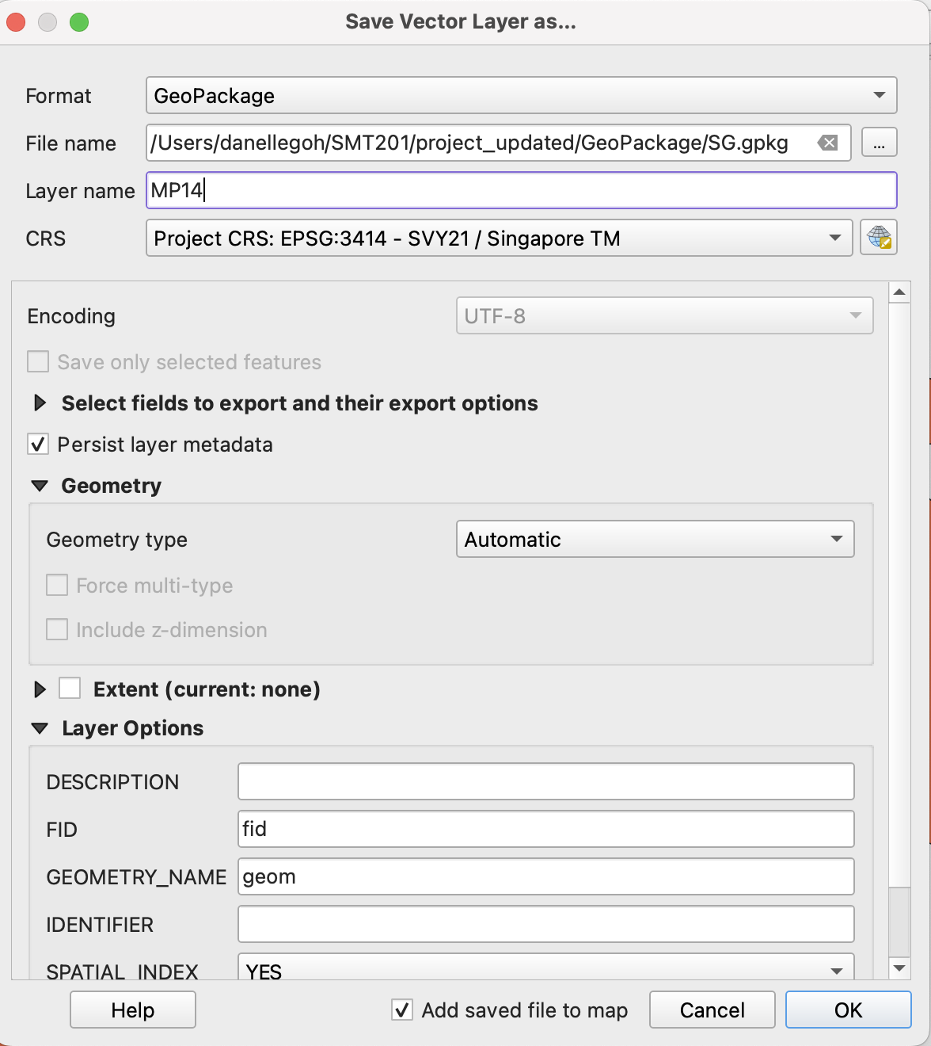

Click **OK**. Once the layer has been saved into the SG GeoPackage, you can remove the original layer.

## 7.2. Preparing schools layer

### 7.2.1. Importing data

Import the csv files for education into QGIS. You can start with the file for before the 2015 merger. Select **Layer** > **Add Layer** > **Add delimited text layer**. The **Data Source Manager** dialog window appears. Open the before merger (2015) CSV file. For Layer name, enter before merger (2015). Under Geometry Definition, select Point coordinates. For X field, select Longitude, and for Y field, select Latitude. For CRS, select EPSG:4326 - WGS 84. Your dialog window should look like the screenshot below.

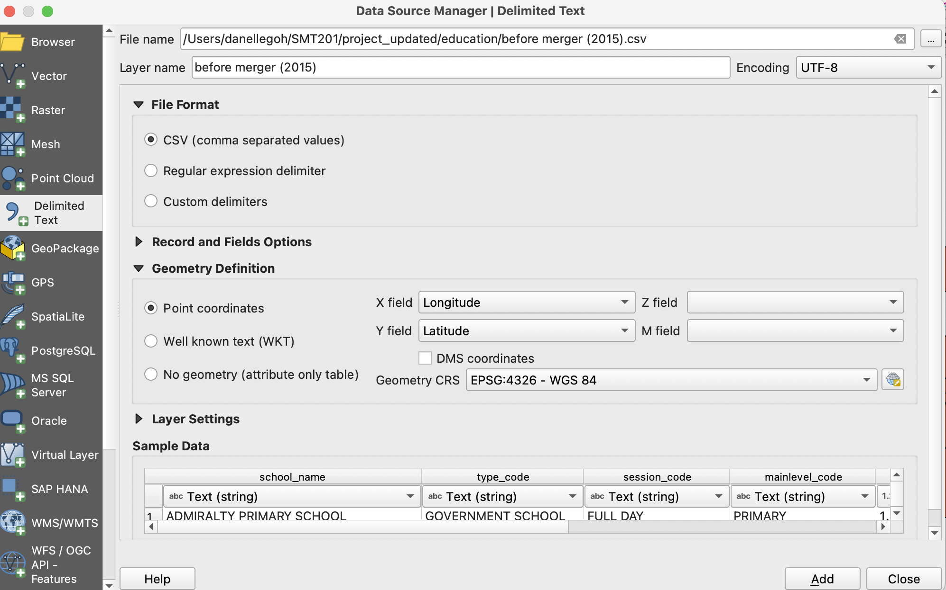

Click **Add**. Click **Close**.

Repeat these steps to import the CSVs for the other years – before merger (2017), before merger (2019), and after merger (2019).

### 7.2.2. Extracting data for respective school types

You will need to extract the data for each of the school types. For our study, we have decided to analyse 3 types – primary schools, secondary schools, and pre-tertiary institutes (junior colleges and others – such as polytechnics and international baccalaureate (IB) schools).

Let’s start with extracting the primary schools for each year.

1. Right click on before merger (2015) and select **Open Attribute Table**. Click on **Select features using an expression**.
2. Click on the arrow in front of **Fields and Values**. Double click on **mainlevel_code**.
3. Click on **=**.
4. Click **All Unique**. Double click on **PRIMARY**.
5. Your expression box should look like the screenshot below.

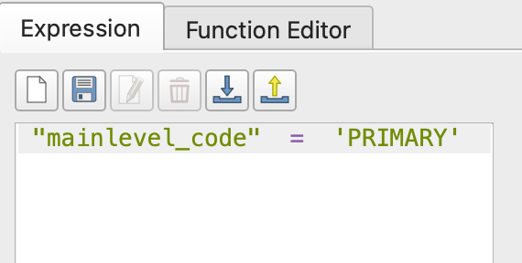

1. Click **Select Features**. Click **Close**.
2. Right click on the layer and save selected features into the SG GeoPackage as bef15_pri.

Repeat these steps above for before merger (2017) (as bef17_pri), before merger (2019) (as bef19_pri), and after merger (2019) (aft19_pri).

Once you have extracted the primary schools for the 4 time periods, repeat these steps to extract secondary schools (with mainlevel_code = ‘SECONDARY’) and pre-tertiary schools (with mainlevel_code = ‘CENTRALISED INSTITUTE’ and ‘JUNIOR COLLEGE’).

## 7.3. Extracting and preparing road network layer

### 7.3.1. Selecting all road network within the study area

Firstly, we will need to import the roads layer from the OpenStreetMap dataset. Select **Layer** > **Add Layer** > **Add Vector Layer**. The **Data Source Manager** dialog window appears. Open the gis_osm_roads_free_1.shp file.

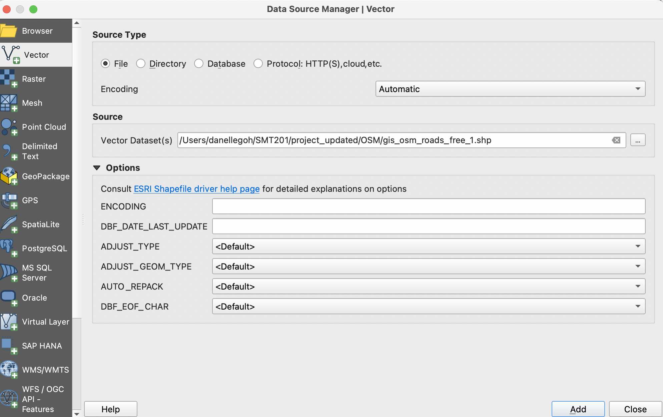

Click **Add**. Click **Close**.

Select **Vector** > **Geoprocessing Tools** > **Clip**.

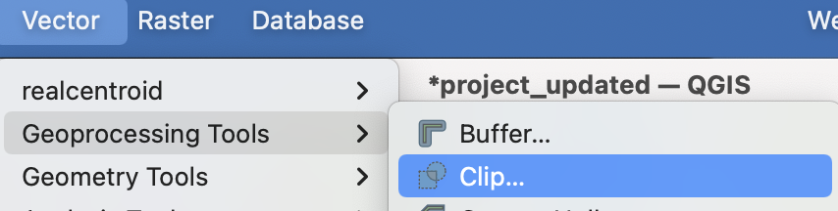

The **Clip** dialog window appears. For Input layer, select gis_osm_roads_free_1.shp. For Overlay, select MP14. Click on the Advanced Options icon. For Invalid feature filtering, select Do not Filter (Better Performance). Your Clip dialog window should look like the screenshot below. When ready, click **Run**.

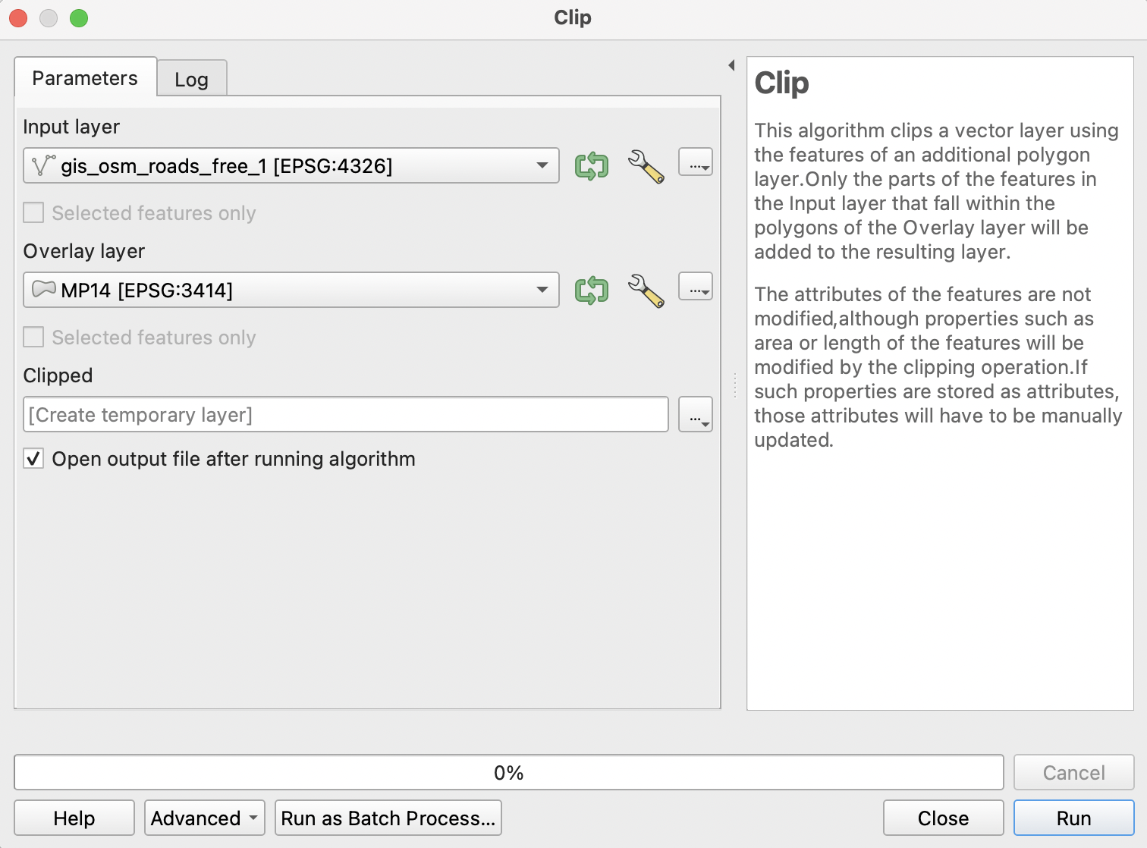

Once the clipped layer has been created, save it into the SG GeoPackage as all_roads. Once saved, remove gis_osm_roads_free_1.shp and the clipped layer.

### 7.3.2. Extracting desired road networks

For each of the school types, we will extract different types of roads. For primary schools, we will only be looking at walking paths. For secondary schools, we will be looking at both walking paths and motor vehicle road networks, For pre-tertiary institutes, we will also be looking at both walking paths and motor vehicle road networks.

We will start with extracting the desired road network for primary schools.

1. Right click on all_roads which we just created, and select **Open Attribute Table**. Click on **Select features using an expression**.
2. Click on the arrow in front of **Fields and Values**. Double click on **fclass**.
3. Click on **=**.
4. Click **All Unique**. Double click on **living_street**.
5. Continue entering the different fclass types into the expression box to extract all the roads for walking paths.
6. Your expression box should look like the screenshot below.

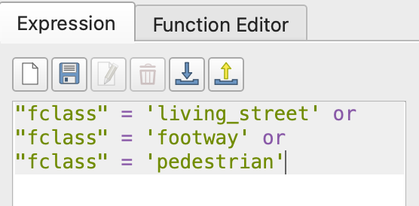

1. Click **Select Features**. Click **Close**.
2. Right click on the layer and save selected features into the SG GeoPackage as roads_pri.

For secondary schools and pre-tertiary institutes, the steps will be similar as before, except that we will be considering more types of roads. The expression box should look like the screenshot below.

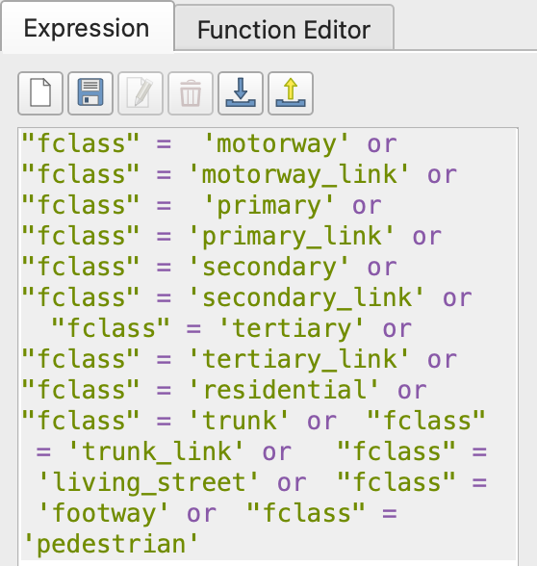

## 7.4. Analytical Hexagon

### 7.4.1. Creating hexagon layer

Select **Vector** > **Research Tools** > **Create Grid**. The Create Grid dialog window appears. For Grid type, select Hexagon (Polygon). For Grid extent, click on the dropdown and select Calculate from Layer. Select MP14.

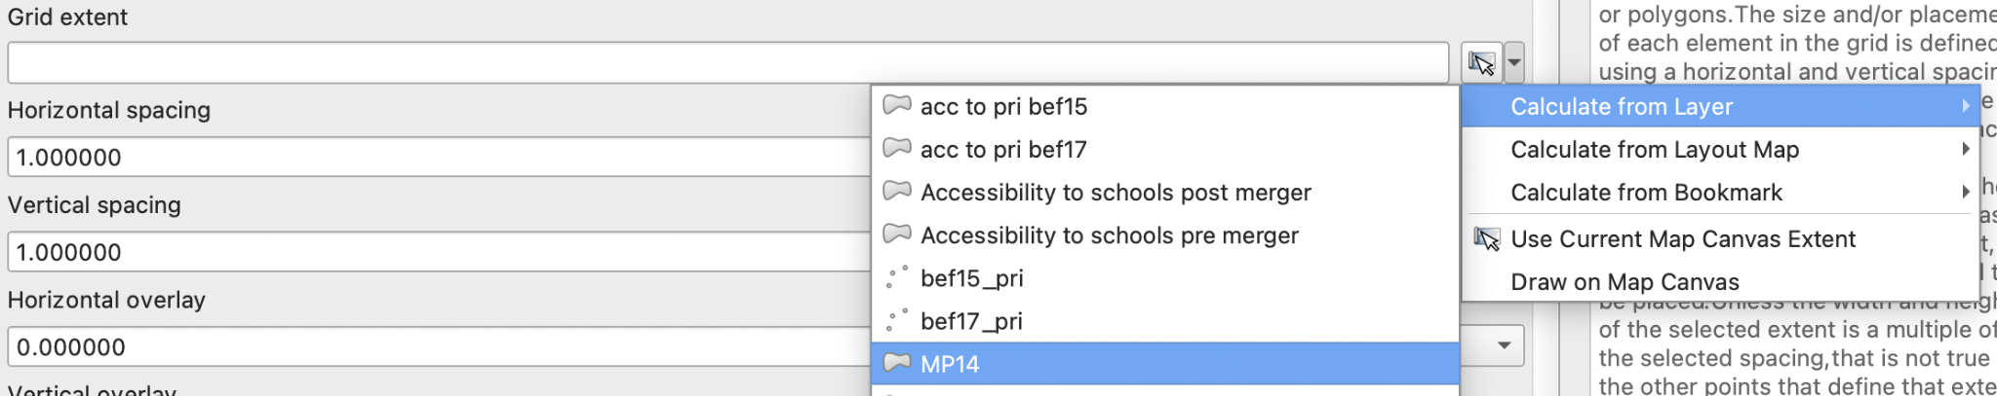

For both Horizontal spacing and Vertical spacing, enter 500. For Grid CRS, select EPSG:3414 - SVY21. Your dialog window should look like the screenshot below. When ready, click **Run**. Click **Close**. A temporary layer called Grid is added on to the Layer pane.

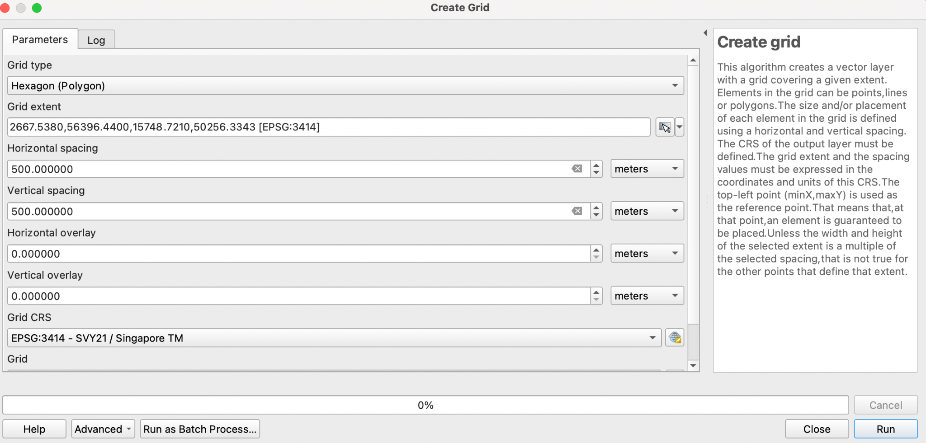

### 7.4.2. Editing and saving the hexagon layer

Select **Vector** > **GeoProcessing** > **Clip**. For Input, select Grid. For Overlay, select MP14. Click on the Advanced Options icon. For Invalid feature filtering, select Do not Filter (Better Performance). When ready, click **Run**. Once the clipped layer has been created, save it into the SG GeoPackage as hexagon14. Once saved, remove the Clipped layer and Grid layer.

### 7.4.3. Computing and saving the hexagon centroid

Select **Vector** > **Geometry Tools** > **Centroid**. For Input layer, select hexagon14. When ready, click Run. Notice that a new temporary layer called Centroid is added onto the Layers panel. Save the layer into SG GeoPackage as hex_centroid14. When done, remove the temporary Centroid layer.

## 7.5. Network accessibility analysis with NEAT3

### 7.5.1. Working with OD Matrix Tool

Select **Processing** > **Toolbox**. At the **Search** pane, type OD Matrix and select **OD Matrix from Layers as Table**. We will need to repeat this for each of the point layers for the different years. We can start with bef15_pri. Your dialog window should look like the screenshots below.

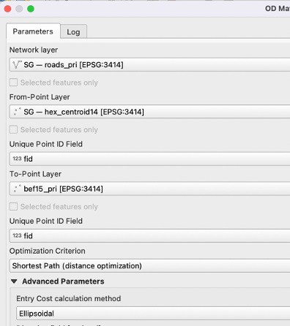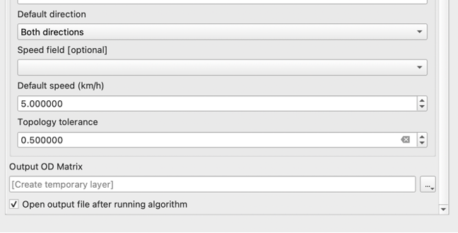

When ready, click **Run**.

When the process has been completed, save the OD Matrix into the SG GeoPackage as ODmatrix_bef15. You can remove the temporary layer.

Repeat the above steps for bef17 (filename: ODmatrix_bef17), bef19 (filename: ODmatrix_bef19) and aft19 (filename: ODmatrix_aft19).

### 7.5.2. Extracting shortest distance pairs

Next, we will use the SQL tool of QGIS to select destination points with the shortest distance. At the **Search** pane of **Processing Toolbox**, type SQL. Double click on Execute SQL of Vector general.

Let’s start with ODmatrix_bef15. For **Additional input data sources**, select ODmatrix_bef15. We will repeat this for the other OD matrices later. In the SQL query box, enter the following statement:

*select fid, origin_id, destination_id, min(total_cost) as shortest_distance*

*from input1 group by origin_id*

For Geometry type, select No geometry. When ready, click **Run**. Notice that a temporary table called SQL Output is added into the Layers panel.

Right click on the SQL Output layer and **Open Attribute Table**. Select **Open Field Calculator** and select **Create a new field**. For Output field name, enter shortestdist_num. For Output field type, select Decimal number (real). For the Expression box, enter “shortest_distance”. Click **OK** and save the changes made.

Save the SQL output into the SG GeoPackage as shortestdist_bef15, and remove the temporary SQL output layer.

Repeat this process for the other years, and save the layers as shortestdist_bef17, shortestdist_bef19 and shortestdist_aft19.

### 7.5.3. Mapping accessibility values

#### 7.5.3.1. Creating a duplicate layer

Before we continue, let us create a duplicate copy of hexagon14 layer. Right click on the layer and select Duplicate Layer. You can rename the layer as “acc to pri bef15”.

#### 7.5.3.2. Performing relational join

Right click on the acc to pri bef15 layer. Select **Properties** > **Joins** > **Add**. For Join layer, select shortestdist_bef15. For Join field, select origin_id. For Target field, select fid. Your dialog window should look like the screenshot below. When ready, click **OK**.

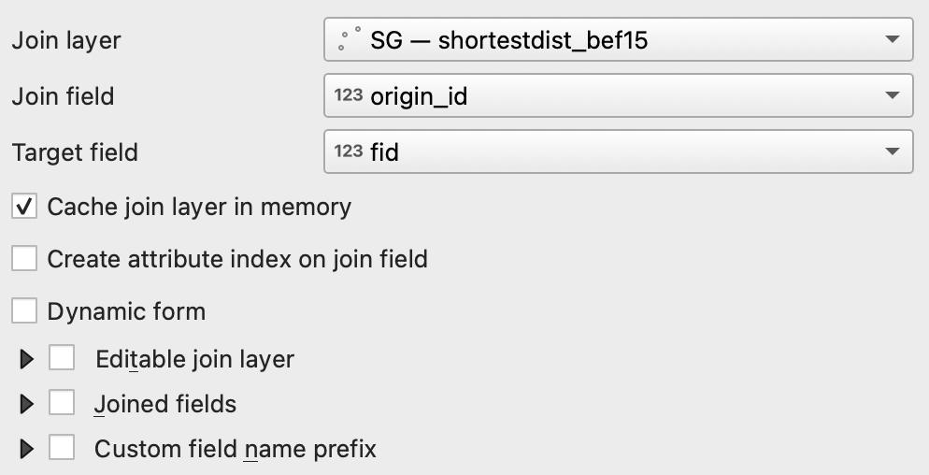

#### 7.5.3.3. Creating choropleth map

Right click on the acc to pri bef15 layer. Select **Properties** > **Symbology**. Select Graduated. For Value, select shortestdist_bef15_shortestdist_num. Change the colour ramp to your preferred colour. For our map, we used blue and inverted the colour ramp. For Mode, select Equal Count (Quantile). Click **Classify**. Your dialog window should look like the screenshot below.

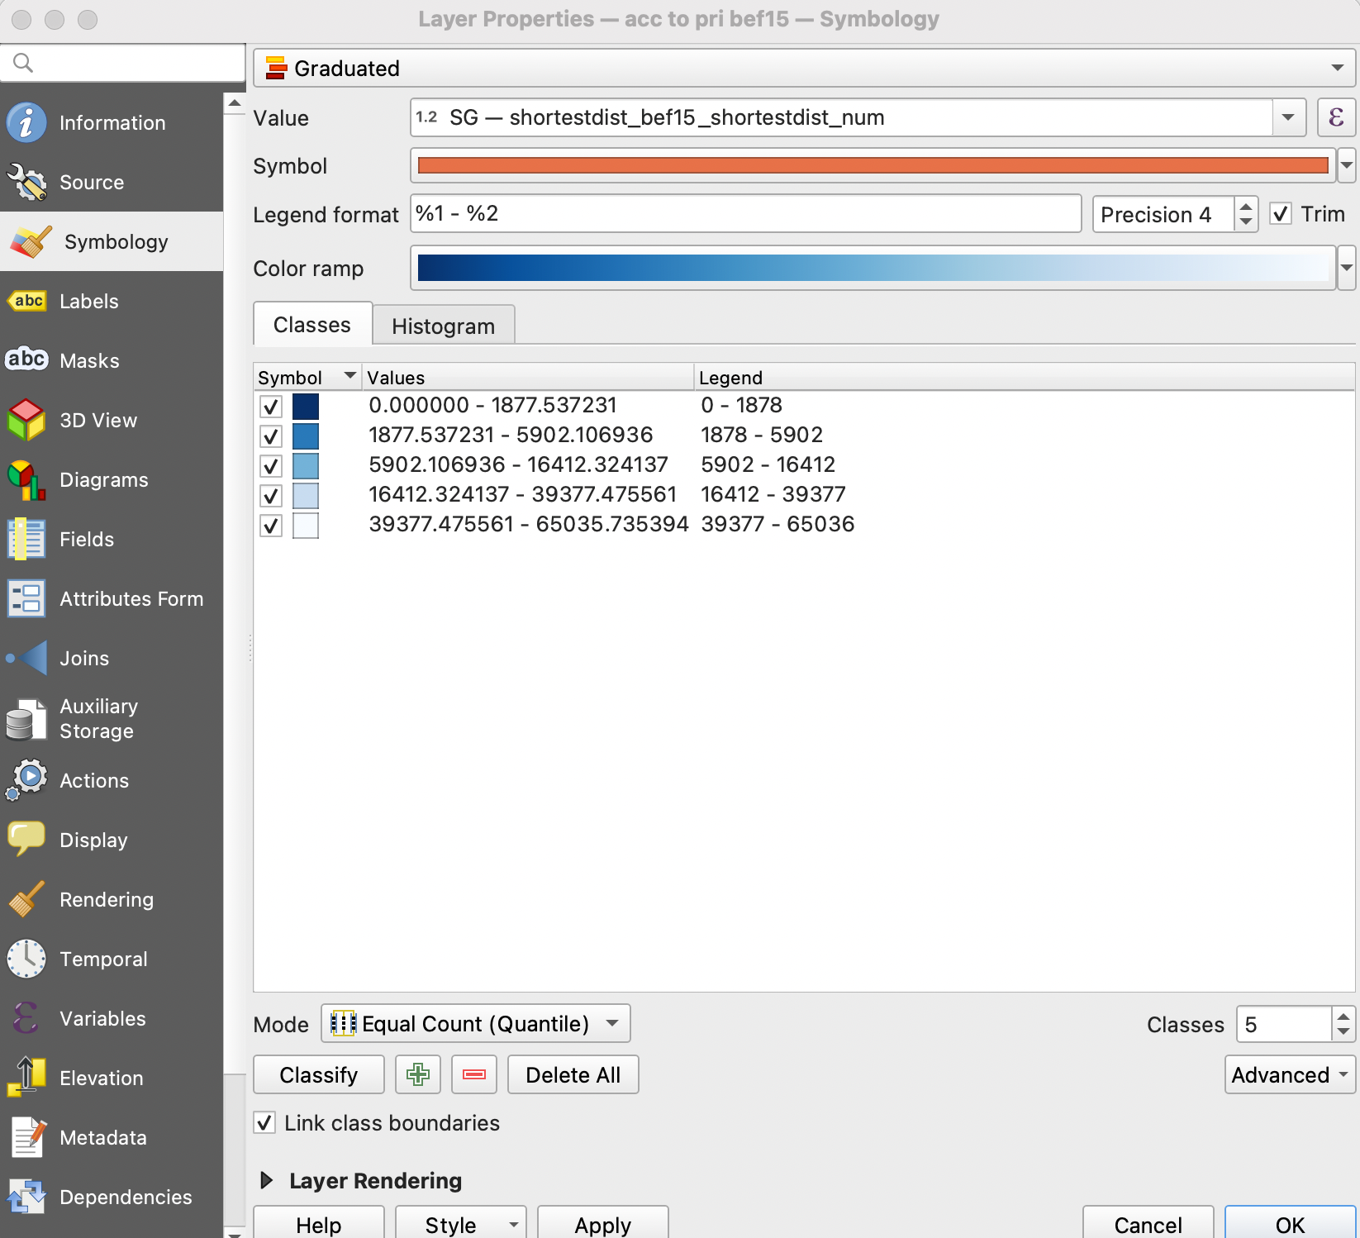

When done, click **Apply** and click **OK**.